

Data Technician

Name:
Course Date:
Table of contents
Day 1: Task 1 3
Day 1: Task 2 3
Day 1: Task 3 4
Day 2: Task 1 5
Day 3: Task 1 9
Day 3: Task 2 10
Day 3: Task 3 11
Day 4: Task 1 12
Day 4: Task 2 13
1. Scenario Background 13
2. Data Laws and Regulations 14
3. Azure Service Recommendations 14
4. Data Types and Data Modelling 14
5. Data Storage Formats and Structures in Azure 14
6. Additional Considerations 15
Submission Guidelines: 15
Course Notes 17
Additional Information 17

Day 1: Task 1

Please research and complete the below questions relating to key concepts of cloud.

Be prepared to discuss the below in the group following this task.

What can cloud computing do for us in the real-world? | It can provide on-demand access to computing power, storage, and software over the internet. It can be used for educational purposes, providing access to, and sharing of, educational resources.
How can it benefit a business? | It means a company doesn’t need expensive physical infrastructure; it enables instant data backup and enhances real-time collaboration on documents. Its cost effective and uses a pay-as-you-go model that allows you to pay for what you use.
What’s the alternative to cloud computing? | The alternatives are physical, on-site local servers. This allows data to kept under direct control, more secure, and removes the need for ongoing subscription fees to third parties.
What cloud providers can we use, what are their features and functions? | AWS – Virtual servers that are reliable with a large ecosystem. Best for businesses needing many services, scalability, and complex architectures.  MS Azure – Azure virtual machines. Integrates with Windows Server, Office 365, and SQL Server with strong hybrid cloud capabilities. This is best for companies using Microsoft products.  GCP – Google compute engine. The advantages of this are strong data analytics, machine learning, and networking. This is best for startups and data-focused businesses.

Day 1: Task 2

Please research the below cloud offerings, explain what they are and examples of use cases.

Cloud Offerings | Explain what it is | When / how might you use this service in the real-world?
IaaS (Infrastructure as a service) | Provides on demand access to IT infrastructure like servers, storage, and networking. | A company might use this as their introduction into cloud computing. It offers flexibility without the large cost of owning infrastructure. This is ideal for businesses that are managing heavy workloads or seasonal spikes. For example, an e-commerce brand scaling it backend to handle festive-season spikes.
PaaS (Platform as a service) | Offers a cloud-based environment with tools to develop, test and deploy applications without managing the underlying hardware. | This is useful if a business needs to deliver a new digital experience quickly. A company might be working on a new customer-facing mobile app. With Paas, they can build, test, and launch the application without needing to acquire new infrastructure. Therefore, development moves faster.
SaaS (Software as a service) | Delivers fully functional software application over the internet, typically through a subscription model, with everything managed by the provider. | A company might use this if they don’t want to invest time or internal expertise in maintaining applications or infrastructure. SaaS allows a team to log in from anywhere and have full functionality. They can get real-time analytics.

Day 1: Task 3

Please research the below terms and explain what they are, when they would be appropriate and a real-world example of where it could be implemented (i.e. what type of organisation).

Public Cloud | Public clouds are managed by third parties which provide cloud services over the internet to the public. These are available as a pay as you go bill. It is a solution for minimizing IT infrastructure costs. Small enterprises can start their businesses without large upfront investments by completely relying on public infrastructure for their IT needs like services for virtual servers, storage, or online applications.
Private Cloud | Distributed systems that work on private infrastructure. Instead of a pay as you go model there could be other schemes that manage the usage of the cloud and proportionally billing of the different departments or sections of an enterprise. Best for government agencies handling sensitive data or high-compliance industries.
Hybrid Cloud | A mix of private and public clouds. Theres more flexibility since it takes advantage of both, it can be scalable like a public cloud and secure like a private cloud. It is best for balancing security needs with the need for high-capacity computing.
Community Cloud | Infrastructure shared by several organisations with common goals or security needs. It can be more cost effective since it is shared across organisations. Very secure. It is adaptable and scalable; users can alter documents to fit their needs. It is used in the healthcare industry to share information and knowledge on a global level with sensitive data.

Day 2: Task 1

Describe, with examples, the three major areas that the Computer Misuse Act deals with.

Area | Description | Example
Unauthorised access to computer material | Accessing, data, files or systems without authorisation. | Logging into someone else’s account without permission.
Unauthorised access with intent to commit further offences | Accessing a computer without permission with the intent to commit further offences. | Offences could be fraud, blackmail, or identity theft.
Unauthorised access with intent to impair/modify | Prohibits altering data or systems without permission. | Damaging systems through viruses, malware, ransomware, or DoS attacks.

The computer misuse act 1990 is an act where an individual can be criminalised because of computer related offense. Describe three extra powers that the Police and Justice Act 2006 (Computer Misuse) has added.

Description
Making, adapting, or supplying articles (malware, hacking tools) with intent to commit a computer misuse offence.

Making DoS attacks explicitly illegal, such as overloading a website with traffic so it stops working.

Increased penalties for committing offences involving unauthorised access to a computer from six months to two years in prison.

Look at the below website to answer the questions:
https://www.gov.uk/personal-data-my-employer-can-keep-about-me

Write down three items of data which a company can store about an employee.
Name

Address

Date Of Birth

Give three more examples of data that an employer can only store if they first get the employee’s permission.
Religion

Race and Ethnicity

Health and medical conditions

Conduct further research to answer the below questions.

Question | Answer
Provide one example of: Copyright infringement | Using a copyrighted photo on a website without permission.
Provide one example of: Plagiarism | Using text copied directly from the source into your work without providing that source.
What are two consequences of copyright infringement and software piracy? | Copyright infringement can result in heavy fines and a severe loss of reputation. Software piracy can result in a higher chance of software failure. As well as no access to ongoing maintenance and support.
Give three possible consequences for individuals when using pirated software | - Slower computer performance  - Vulnerable to cybersecurity attacks  - No warranty

Listed below are some laws which we have covered today:

1. Computer Misuse Act 1990
2. Police and Justice Act 2006 (Computer Misuse)
3. Copyright, Designs and Patents Act 1988
4. Copyright (Computer Programs) Regulations 1992
5. The Health and Safety (Display Screen Equipment) Regulations 1992
6. Data Protection Act 2018
7. Consumer Rights Act 2015

- Insert a number in the first column of each row to match each of the statements with one of the above Acts.

- One of statements is incorrect and not illegal. For this statement, write ‘Not illegal’.

Act number | Clause
1 | With some exceptions, it is illegal to use unlicensed software
7 | Any product, digital or otherwise, must be fit for the purpose it is supplied for
6 | Unauthorised modification of computer material is illegal
Not illegal | It is illegal to create or use a hacking tool for penetration testing
6 | Personal data may only be used for specified, explicit purposes
5 | Employers must provide their computer users with adequate health and safety training for any workstation they work at
2 | It is illegal to distribute hacking tools for criminal purposes
2 | It is illegal to distribute an illicit recording
6 | Personal data may not be kept longer than necessary
1 | Gaining unauthorised access to a computer system is illegal
5 | Employers must ensure that employees take regular and adequate breaks from looking at their screens
1 | It is illegal to prevent or hinder access (e.g. by a denial-of-service attack) to any program or data held in any computer
6 | Personal data must be accurate and where necessary kept up to date

Day 3: Task 1

Please complete the below lab (3) ‘Explore relational data in Azure’ and paste evidence of the completed lab in the box provided.



Completed lab | 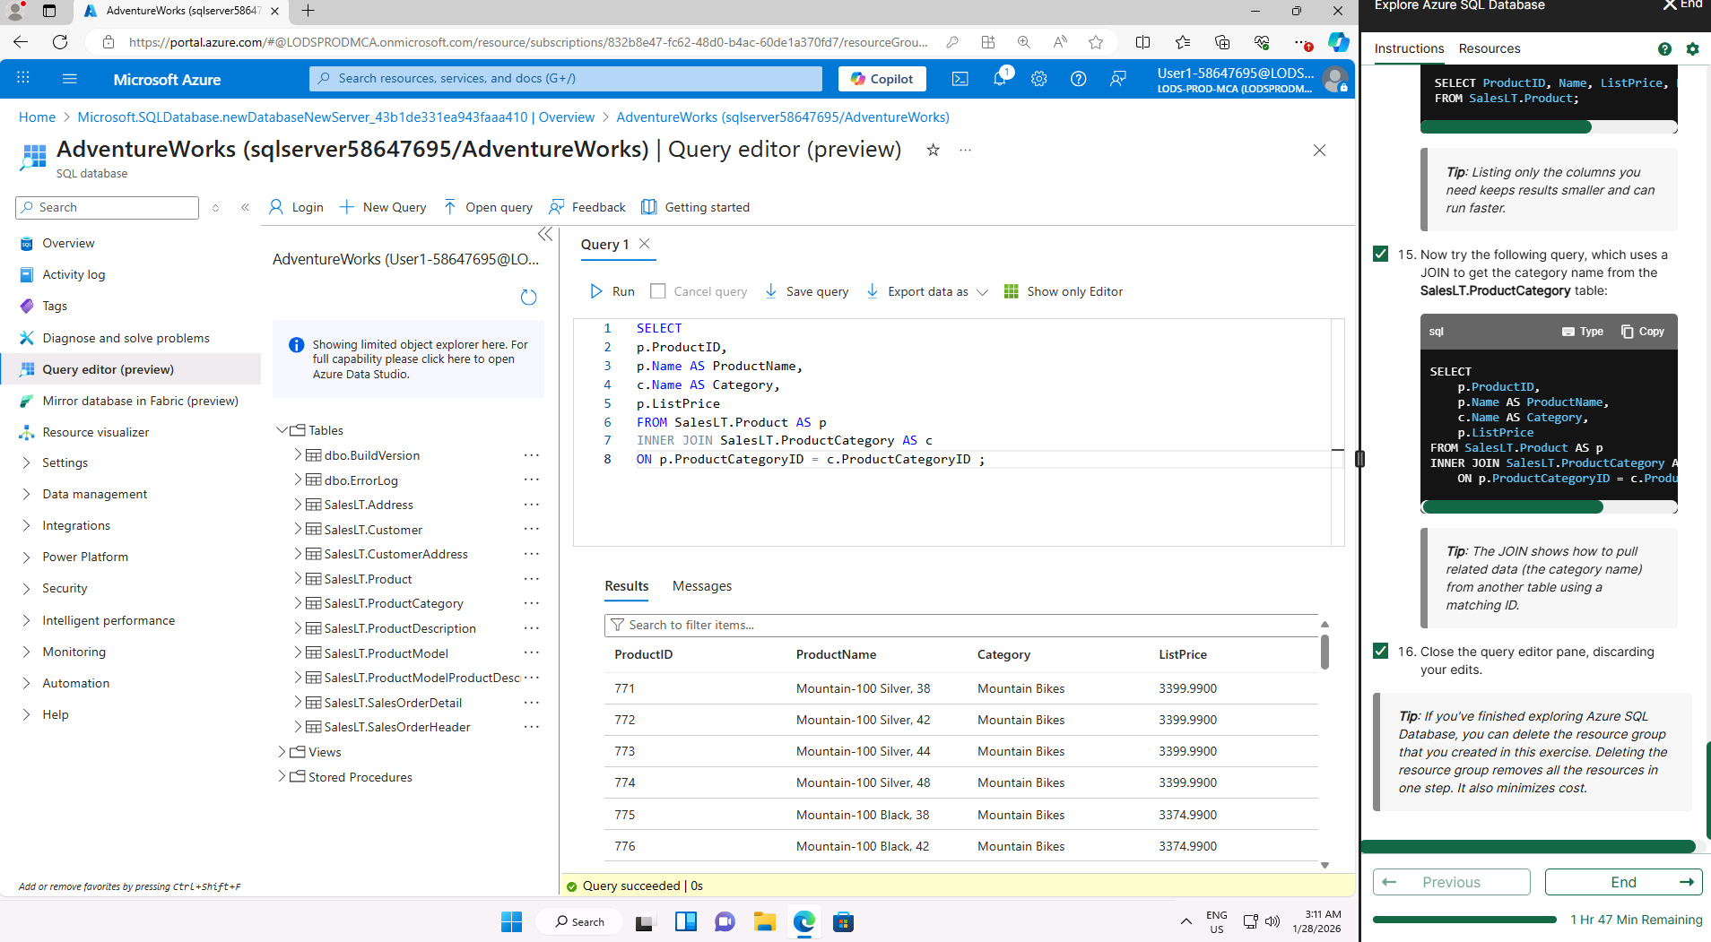

Day 3: Task 2

Please complete the below lab (4) ‘Explore non-relational data in Azure’ and paste evidence of the completed lab in the box provided.



Completed lab | 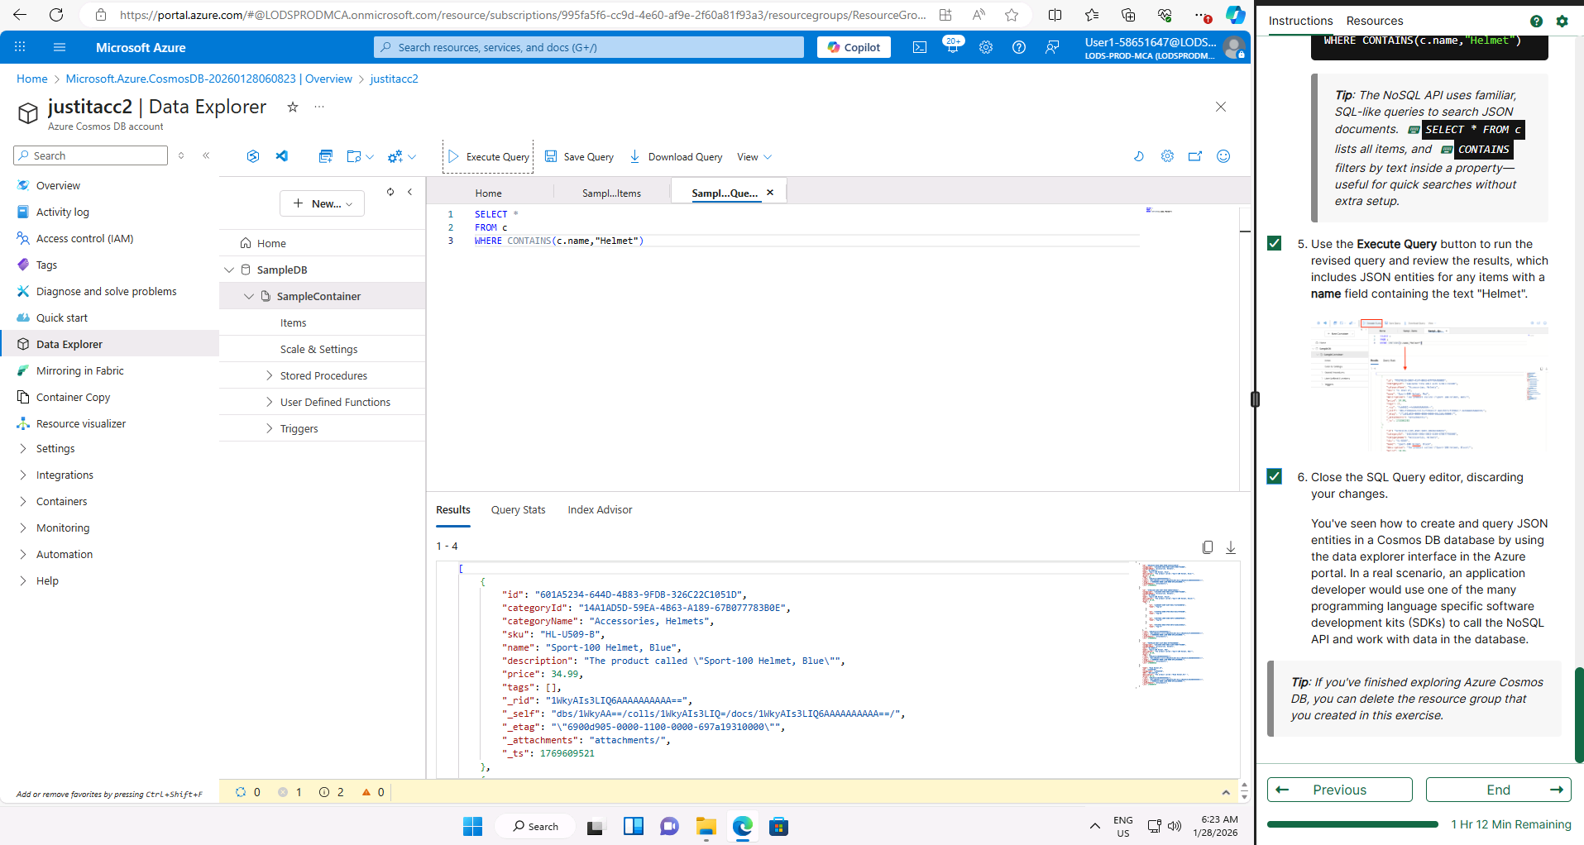

Day 3: Task 3

Please complete the below lab (5) ‘Explore data analytics in Azure’ and paste evidence of the completed lab in the box provided.

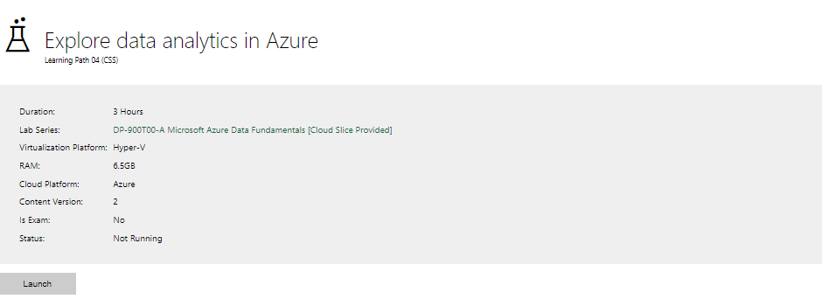

Completed lab | 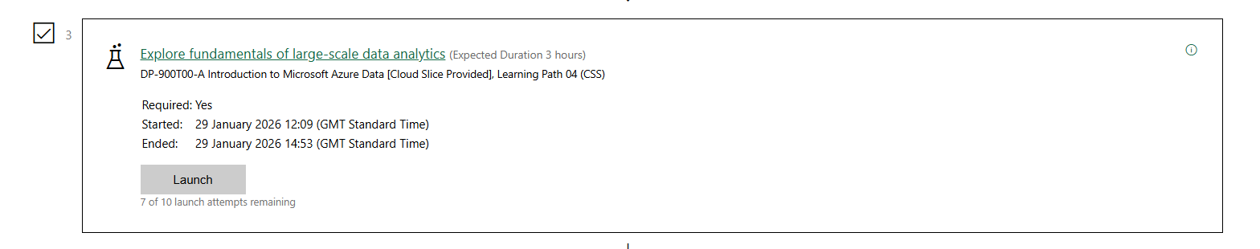

Day 4: Task 1

In your teams, complete the Azure DP-900 practice exam and paste your result below – this is open book and please research and discuss your answers as a team.


Result | 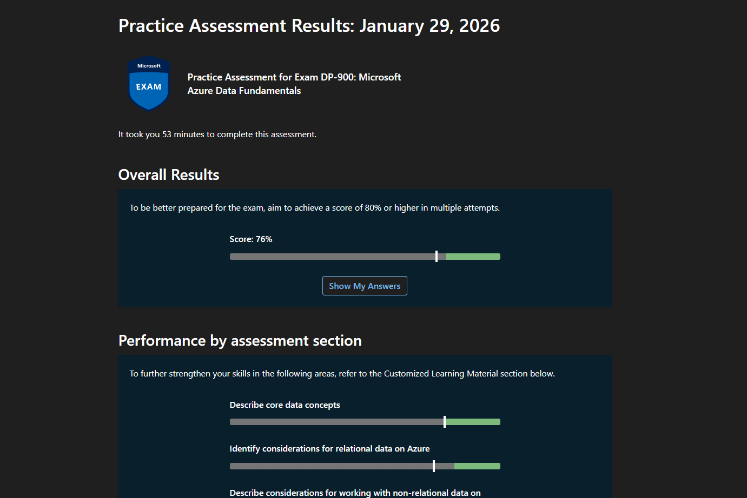

Day 4: Task 2

1. Scenario Background
"Paws & Whiskers" is a growing pet shop that aims to improve its business by analysing sales, customer information, and inventory data. Currently, the data is collected manually or stored in spreadsheets. Management is interested in transitioning to Microsoft Azure to streamline data storage, analysis, and reporting, enabling them to make data-driven decisions.

2. Data Laws and Regulations
Identify and explain the data laws and regulations relevant to handling customer data within the proposal. Ensure you cover the following points:
- GDPR Compliance: Highlight the importance of adhering to the General Data Protection Regulation (GDPR), particularly as it relates to storing and processing customer information.
- Data Protection Act (DPA) 2018: Outline how the DPA 2018 may affect the way "Paws & Whiskers" collects and stores data, ensuring compliance with UK laws on data privacy.
- Other Industry Standards: Research any additional data protection standards or regulations that may apply to pet shop data, particularly if they involve sensitive or payment information.

3. Azure Service Recommendations
Recommend Microsoft Azure services that would suit the company’s data analysis needs and explain why these services are suitable. Your recommendations should include:
- Data Storage: Identify suitable storage options, such as Azure Blob Storage or Azure SQL Database, and discuss the benefits of each for storing large datasets, including inventory, sales transactions, and customer details.
- Data Analysis Tools: Recommend tools such as Azure Machine Learning for customer behaviour analysis or Azure Synapse Analytics for analysing sales trends.
- Data Integration and Automation: Explain how services like Azure Data Factory could automate data collection and integration processes, improving efficiency.

4. Data Types and Data Modelling
Define the types of data "Paws & Whiskers" will need to work with and describe your approach to data modelling:
- Data Categories: Identify key data types, such as customer demographics, transaction history, pet inventory, and product categories.
- Data Modelling Approach: Outline how you would structure this data using a relational model or a data warehouse approach, considering factors like tables, entities, relationships, and primary keys.

5. Data Storage Formats and Structures in Azure
Discuss how you would store data within Azure and the formats you would recommend:
- Data Formats: Specify recommended formats (e.g., CSV for raw data imports, JSON for structured data, Parquet for analytics) and explain why these formats are suitable for specific data types.
- Data Security and Encryption: Include recommendations for securing data using Azure’s built-in encryption features and access controls to ensure compliance with data privacy regulations.

6. Additional Considerations
Provide any other considerations that might enhance data handling and efficiency in Azure, such as:
- Backup and Disaster Recovery: Outline a backup plan using Azure Backup or Azure Site Recovery to safeguard against data loss.
- Data Visualisation: Discuss potential use of Power BI within Azure for creating dashboards that provide management with real-time insights into sales and customer trends.
- Future Scalability: Comment on how Azure services can scale as the business grows, accommodating larger datasets and more complex analyses.

Submission Guidelines:
- Structure: Ensure your report is well-organised, with sections for each task (e.g., Data Laws, Azure Services, Data Types, etc.).
- Formatting: Include headings, bullet points where appropriate, and any visuals or diagrams that support your explanations.
- References: Cite any resources or regulations referenced in the report.
- Length: Aim for 1500-2000 words.

Data Laws and Regulations:
“Paws and Whiskers” need to ensure that they handle their customers data responsibly. This is because it ensures they maintain their reputation and their customers trust additionally to be legally compliant. The biggest example of this is GDPR which state how data should be collected, stored, and processed. It allows customers to be in control of their personal information, Paws and Whiskers will be collecting clients online account information, and customer names. GDPR has seven key principles that must be followed, these are
- Lawfulness, Fairness, and Transparency
  - Data must be processed legally; customers must know how their data is being used.
- Purpose Limitation
  - Data should only be collected for a specific purpose.
- Data Minimisation
  - Only the necessary amount of data should be collected.
- Accuracy
  - Data must be accurate and up to date.
- Storage Limitation
  - Data should not be kept longer than needed.
- Integrity & Confidentiality
  - Data must be kept safe and secure from unauthorised breaches.
- Accountability
  - Paws and Whiskers must be able to prove they are following this legislation.
Another prominent piece of legislation Paws and Whiskers will have to comply with is the Data Protection Act 2018. The Data Protection Act implements GDPR into UK law as a result it also aims to implement privacy and ensure data is collected, stored, and handled responsibly. Much like GDPR. The Data Protection Act explores four key areas
- General Data Processing
- Law Enforcement Processing
- Intelligence Services Processing
- Regulation and Enforcement
This affects Paws and Whiskers because they need to ensure that their reasons for processing data align with the standards of this legislation. For example, how the customer consent is obtained and recorded, how securely has the personal data been stored, and their rights to access their data or have it deleted.

Additional industry standards might include Payment Card Industry Data Security Standard (PCI DSS). If they process cards payments protects customers against potential misuse of their personal information. Such as, credit/debit card numbers, expiration dates and security codes. The standard’s security controls help business minimise the risk of data breaches.

Azure Service Recommendations:
Microsoft Azure offers a range of services suitable for Paws and Whiskers needs to store, analyse, and manage data effectively.
Data Storage
- Blob Storage
  - Ideal for storing massive volumes of unstructured data. This could be ideal for transaction logs. Its good because its scalable, simple, and cost effective. It provides built-in encryption and there are multiple blob types so they can easily match their workload requirements.
- Azure SQL Database
  - This is a relational database best suited for storing customer records and inventory lists. It includes high scalability and performance. It enables them to take advantage of the clouds flexibility and efficiency to scale their database on demand so they only must pay for the resources that they use.

Data Analysis Tools
- Azure Machine Learning
  - Can be used to predict purchasing trends or customer behaviour.
- Azure Synapse Analytics
  - Ideal for analysing large data sets such as product performance.

Data Integration and Automation
- Azure Data Factory
  - Azure Data Factory can help to automate their processes by using automated data extraction and transformation. It can gather data from online sales platforms or inventory systems into a single data store. Automating the process and mitigating risk of human error.

Data Types and Data Modelling
- Data Categories
  - Customer demographics – what is their name, email address, phone number. What is their age and where do they reside.
  - Transaction data – what is their purchase history, common trends in their spending habits.
  - Pet inventory – what types of animals will they stock, what specific care needs will the customer need to know and what will the length of ownership be.
  - Product Categories – group the animals by type. Identify other products like food, toys, treats.
- Data Modelling Approach
  - A relational data model is best since this data is structured and can be stored in a tabular format.
  - They would need tables such as Customers, Orders, and Inventory
  - This data model would need primary keys (unique identifiers) and foreign keys (primary keys present in other tables) so they can define relationships between tables.
  - Customer data – customer id, first name, last name, phone number
  - Transaction data – transaction id, items bought, purchase date, customer id, inventory id
  - Inventory data – inventory id, stock levels, pricing
  - In this case, three tables all contain a primary key and there are two foreign keys found in the transaction data table. This defines the relationships between these table allowing for insights and analysis. For example, the primary key in the customer data table can also be found as a foreign key in the transaction data table.
  - For analysis a star schema can be used.
    - Fact tables for transaction data
    - Dimension tables for inventory and customer data

Data Storage Formats and Structures in Azure:
- Data Formats
  - CSV is suitable for raw data imports from tills or third-party systems. Very easy to read and write, it becomes less effective with bigger files.
  - JSON is ideal for semi-structured data such as API responses or web data.
  - Parquet is recommended for analytics in Azure Synapse due to it compressed, column-based format, which improves performance.
- Data Security and Encryption
  - They can secure data by enabling the Azure default encryption-at-rest.
  - They can implement Role-Based Access Control to limit data access, though it is important that data can still be accessed to ensure compliance with data privacy regulations.
  - They can also achieve this by utilising Microsoft defender for cloud for continuous monitoring, threat detection, and receive security recommendations.
  - They can also use Microsoft Purview to identify, classify, and protect sensitive data.

Additional Considerations
- Backup and Disaster Recovery
  - Azure backup can provide automated backups of databases and storage accounts.
  - Azure site recovery ensures can ensure continuity by replicating data to secondary locations in the event of a system failure.
- Data Visualisation
  - Power BI can be integrated with Azure SQL database and Synapse analytics to create dashboards that could show
    - Sales performance
    - Best-selling products
    - Customer purchasing trends
  - Providing Paws and Whiskers with real-time insights in which they can make informed decisions from.

Cites and Sources:
https://www.virtual-college.co.uk/resources/the-data-protection-act-2018
https://www.gdpradvisor.co.uk/what-is-gdpr
https://www.techtarget.com/searchsecurity/definition/PCI-DSS-Payment-Card-Industry-Data-Security-Standard
https://learn.microsoft.com/en-us/
https://www.logicmonitor.com/blog/what-is-azure-blob#h-azure-blob-storage-with-adls-gen2-for-big-data-and-analytics
Regulations:
Data Protection Act 2018
GDPR 2018
PCI DSS 2004

Course Notes

It is recommended to take notes from the course, use the space below to do so, or use the revision guide shared with the class:

Additional Information

We have included a range of additional links to further resources and information that you may find useful, these can be found within your revision guide.

END OF WORKBOOK

Please check through your work thoroughly before submitting and update the table of contents if required.

Please send your completed work booklet to your trainer.

